1 – AD DS and DNS roles installed. 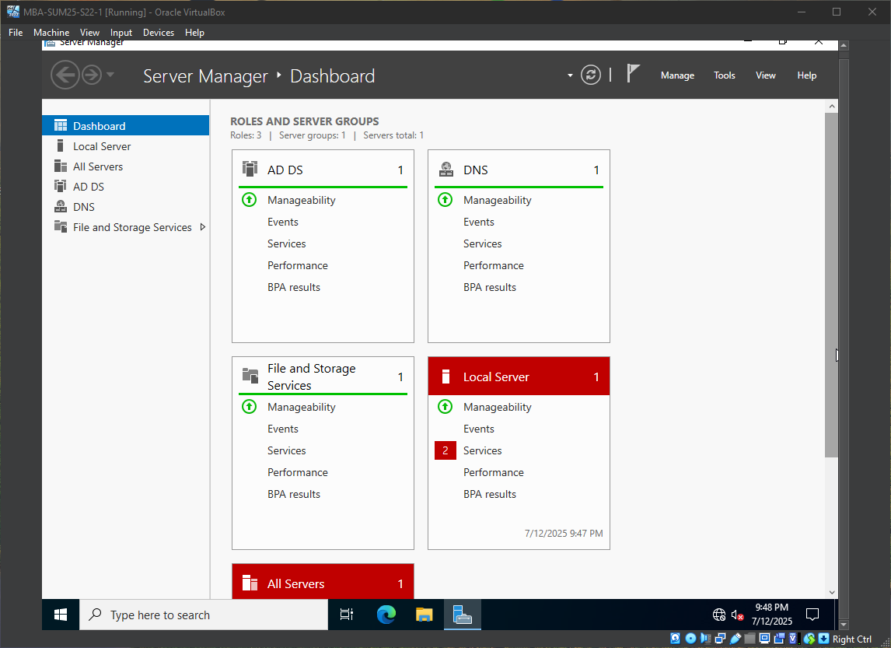
2 – MBA-SUM25-S22-1 in savn.local domain. 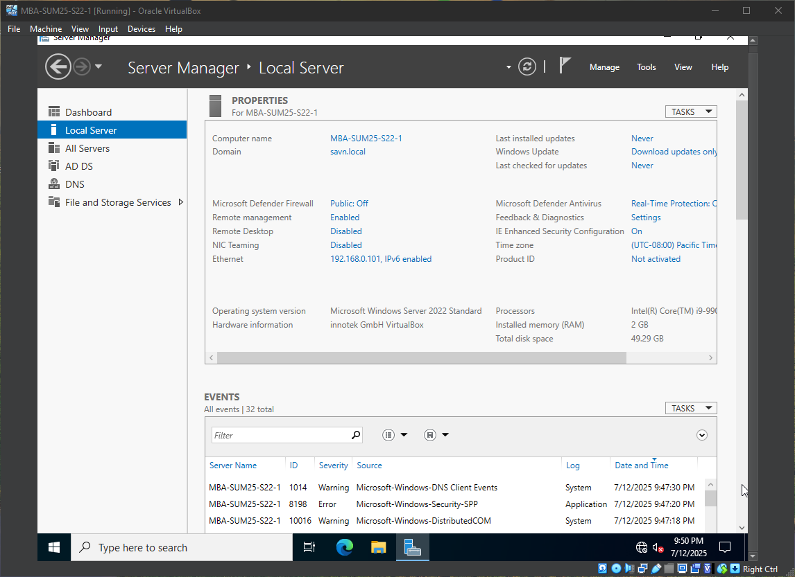
3 – MBA-SUM25-S22-1 set as domain controller for savn.local.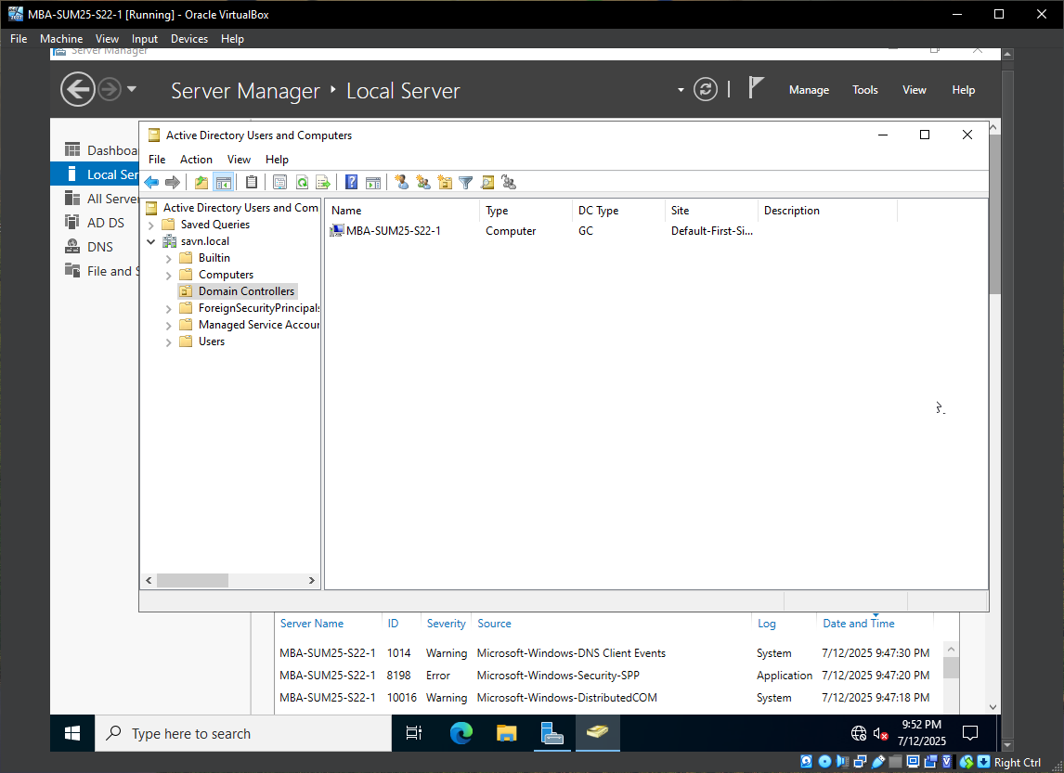
4 – MBA-SUM25-S22-2 joins savn.local domain.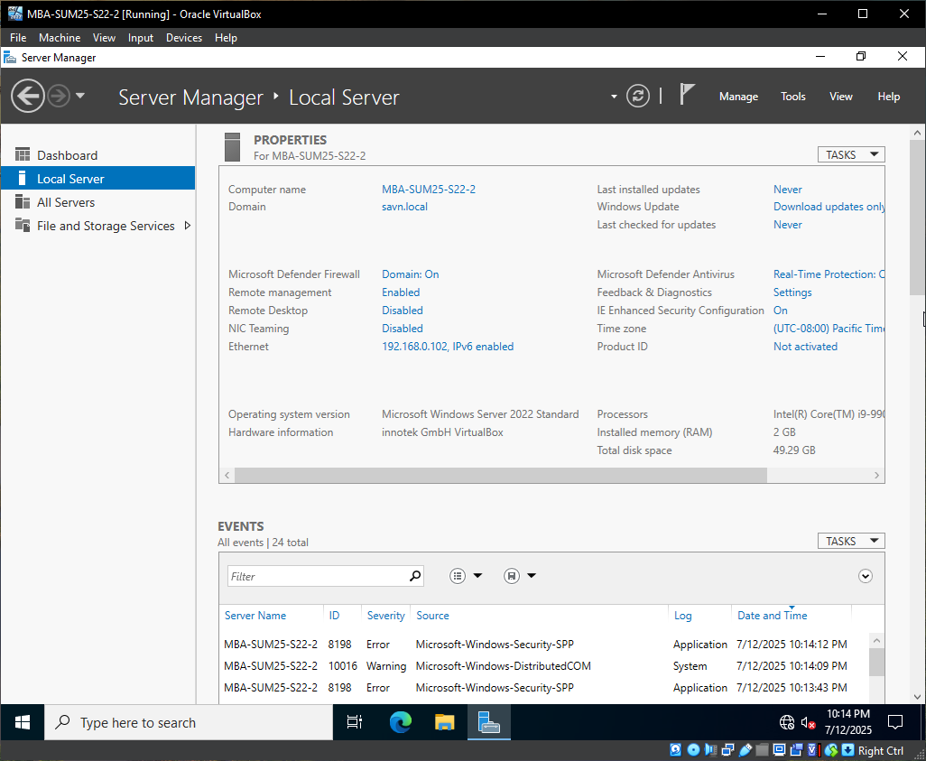
5 – MBA-SUM25-W10-1 joins savn.local domain.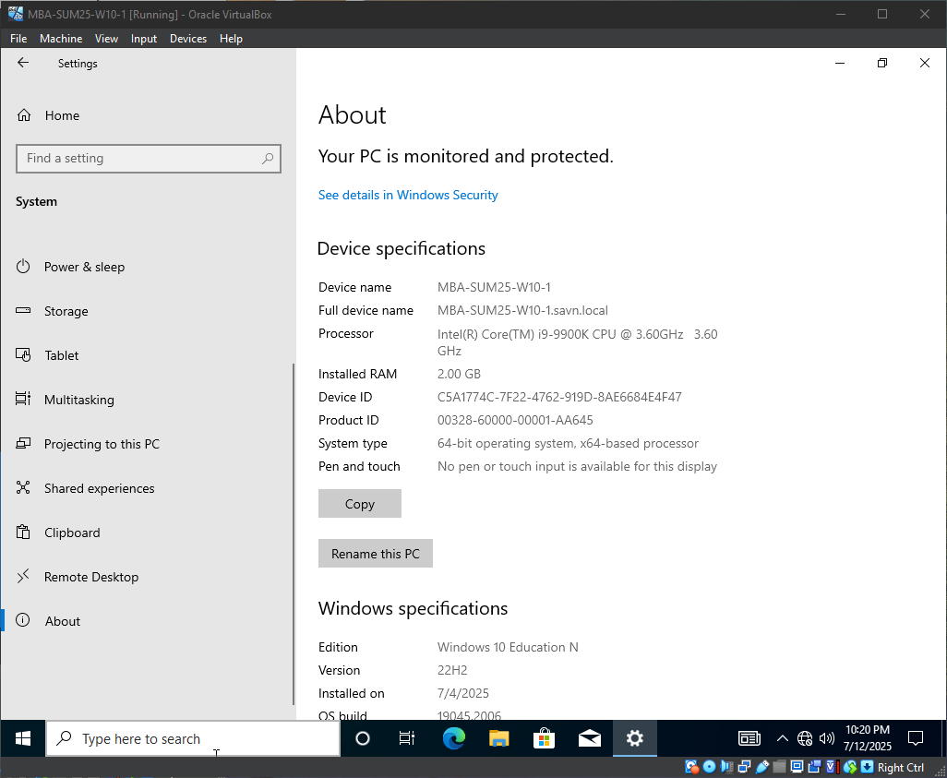
6 – Computers in savn.local AD. 